SPREADSHEETS

Name:

1. Complete the paragraph below by using each word in the table once only.

|  |  |  |  |  |
| --- | --- | --- | --- | --- |
|  | RECALCULATED |  | DIVIDE |  |
| CALCULATIONS |  |  | SPREADSHEET |  |

A spreadsheet is a ___PROGRAM________ which makes it easy for you to work with numbers. It consists of a page made up from _____COLUMNS__________ and rows which are arranged into a ___GRID____. You can identify every single cell on a spreadsheet by its unique cell _______REFERENCE__________, made up from the ____ROW_ number and column letter, for example A6, E14, N45. Numbers, text or ____FROMULAS_________ can be entered into each cell. Formulas allow you to perform ______CALCULATIONS__________ on the numbers in your spreadsheet. You can add, subtract, multiply and ______DIVIDE_____ numbers by using formulas. Using formulas is a very good idea, because it means that once your spreadsheet is set up, any changes you make to one area are automatically ________RECALCULATED_______throughout the ______SPREADSHEET______________.

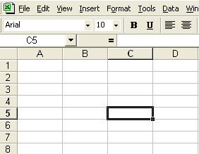

# 2. Label the different parts of this spreadsheet

|  |  |
| --- | --- |
| CELL | ACTIVE CELL |
| TOOLBAR | MENU |
| ROW | COLUMN |

How many rows are shown on this spreadsheet? ………8………………………………..

How many columns are shown on this spreadsheet? ..……………4……………………

E5

What is the cell reference of the active cell? ………………………………………………

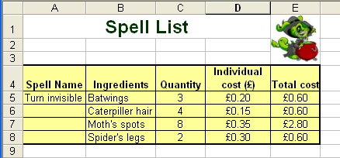

1. Give a cell reference which contains a label

………………………………………………………C4 GO BOOM………………………………………………………

2. Which column letter contains the individual cost of ingredients?

………………………………………………………………d5………………………………………………

3. Which row number contains the spell name?

………………………………………………………a5………………………………………………………

4. Which cell reference contains the title ‘ingredients’ ?

B4

………………………………………………………………………………………………………………

5. Which cell reference contains the quantity of Moth’s spots needed?

B7

………………………………………………………………………………………………………………

6. Give a cell reference which contains a value

………………………………………………………………………c5………………………………………

7. Give a cell reference which contains a formula

E5

………………………………………………………………………………………………………………

8. Write the formula used to work out the total cost of catterpillar hair required.

=c6*d6

………………………………………………………………………………………………………………

9.The individual cost of Batswings has gone up from £0.20 to £0.25. Which two cells will change as a result of this price increase?

**Total Marks:**

/29

…………………………………………d5 e5…………………………………